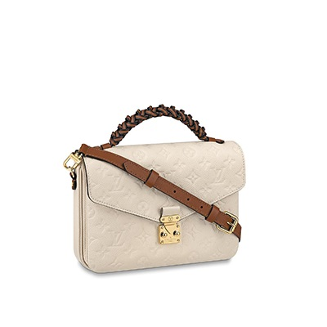

Pochette Métis Monogram Empreinte Leather

PRODUCT DETAILS

**L 9.8 x H 7.5 x W 2.8 inches**

**- Crème Beige and Caramel**

**- Embossed supple grained cowhide leather and supple grained cowhide leather**

**- Supple grained cowhide -leather trim**

**- Microfiber lining**

**- Gold-color hardware**

**- Leather short braided handle for hand carr y**